COA LAB – 6

1. The Fibonacci Sequenceis the series of numbers: 0, 1, 1, 2, 3, 5, 8, 13, 21, 34,. . .. Any number in the series is found by adding up the two numbers before it.Write a MIPS program to perform the following: Given a positive integer 0≤n≤20, store the first n numbers of the Fibonacci series and print them

Ans.

Code (The code can be found in the file named 1.asm in the attachments)

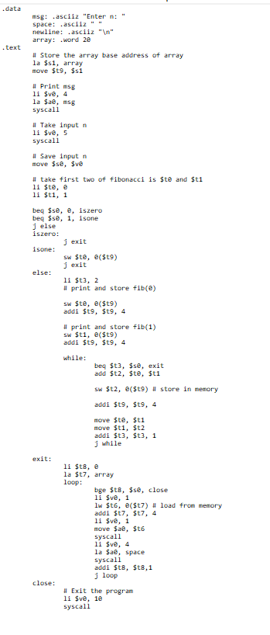

Output

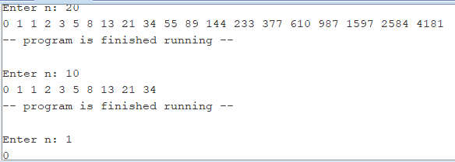

1. Write a program in MIPS assembly language program to convert lowercase letterin a user given characterto upper case letter.

Ans.

Code

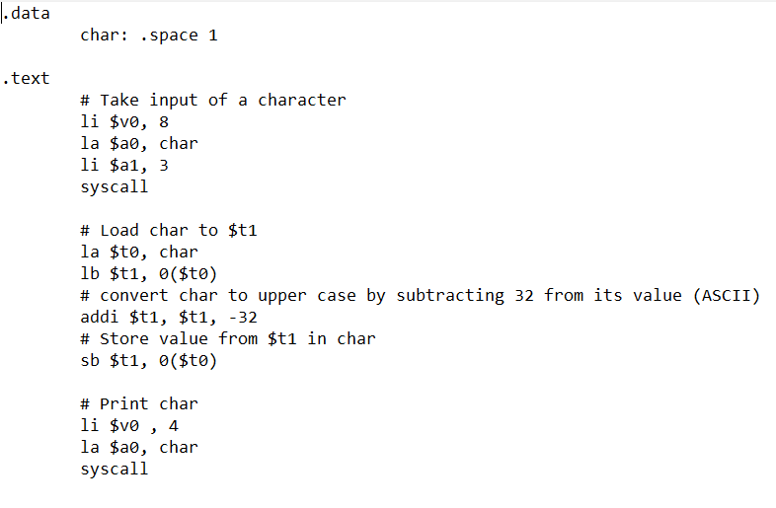

Output (for inputs b and z separately)

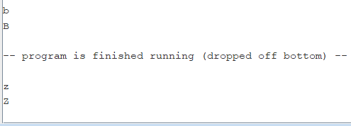

1. Write a program in MIPS to count the number of 1's in the number provided.

Ans.

Solution:

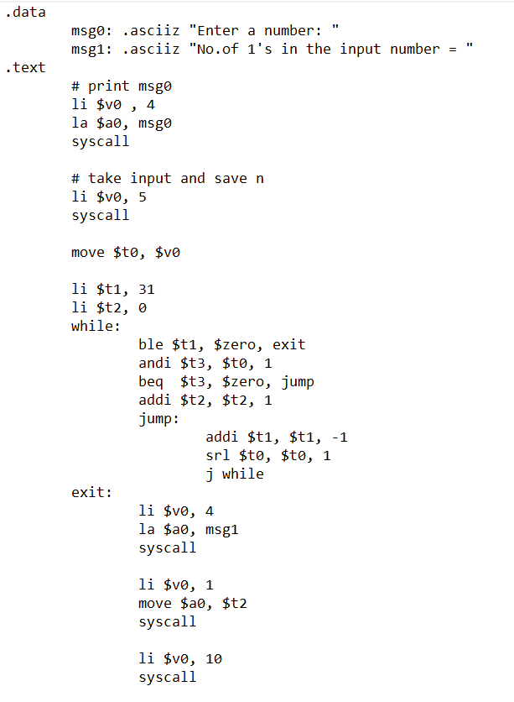

Output

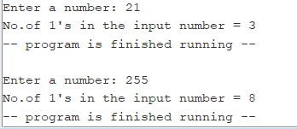

4. Write a MIPS program to compute the factorial of a positive number ( >1).

Ans.

Code

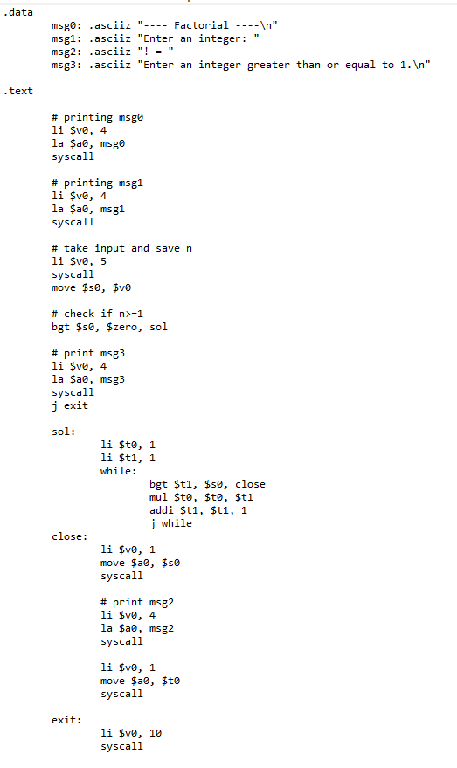

Output

The result will be accurate only upto 12! since from 13! , more than 32 bits are needed to store the answer.

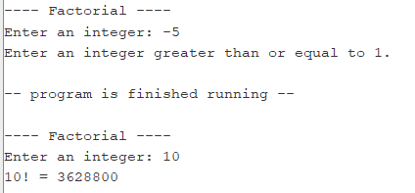

5. Consider thecode below. Translate the code into MIPS instructions as directly as possible. Put them in a file called array.s. int[] a = new int[5]; a[0] = 3;a[4]= a[0] -1;Run your code to make sure it has correct behavior. You should make sure the memory locations of the array hold the expected values.

Ans.

Please go to next page.

Solution

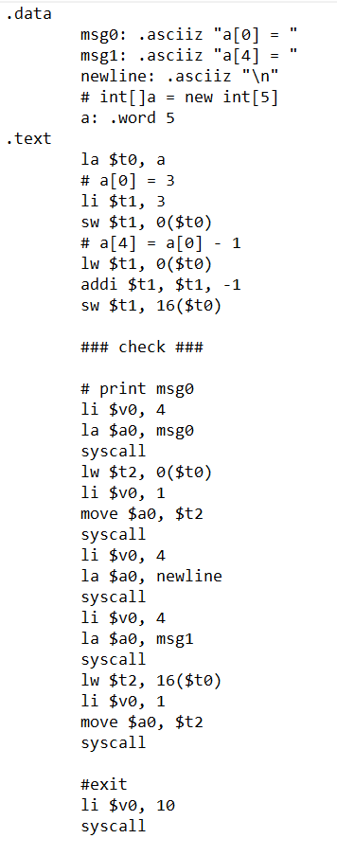

Output

